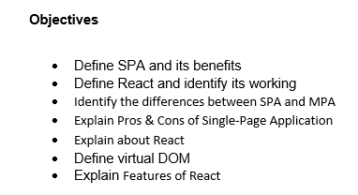

1. A **SPA (Single Page Application)** is a web app that loads a single HTML page and dynamically updates it as the user interacts with the app.

The benefit of SPA is listed below:

* Elimination of full page reload.
* More responsive and engaging user experience.
* Works well with APIs
* Reduces server load

1. **React** is a **JavaScript** library used for building user interfaces.  
    It works by creating components, which are reusable blocks of UI. React uses a **virtual DOM** to update only the parts of the page that change, making it fast. It’s component-based structure and **Single Page Application**, enables efficient UI updates.

|  |  |
| --- | --- |
| **Single Page Application (SPA)** | **Multi Page Application (MPA)** |
| A Single Page Application loads one HTML page initially and updates content dynamically. | A Multi Page Application reloads the entire HTML page from the server for each new page request. |
| These are faster after the first load because only the required data is updated. | These are generally slower because each page load fetches all resources again. |
| They provide a smooth and seamless user experience without full page reloads. | They may flicker or lag during navigation as each link causes a full page reload. |
| They use client-side routing (e.g., with React Router) to manage URL changes. | They rely on server-side routing, where each URL change reloads a new page. |

1. Pros of SPA are:

* Single Page Applications offer faster interactions because they only update parts of the page.
* They provide smooth navigation as there is no full page reload during route changes.
* They are well suited for mobile application due to better performance and responsiveness.

Cons of SPA are:

* Single Page Applications can face Search Engine Optimization (SEO) issues since content is loaded dynamically.
* They may have a large initial load time as all necessary scripts are loaded upfront.
* They can be complex to build and maintain due to client-side routing and advanced JavaScript logic.

1. React is a JavaScript library made by Facebook. It is used to build interactive user interfaces. It makes it easy to create **components**, update UI efficiently using **virtual DOM**, and manage data in the frontend.
2. **Virtual DOM** is a lightweight copy of the actual document object model or better called as **DOM**. React uses it to find out what changed and updates only that part, instead of reloading the whole page.
3. The features of React are listed below:

* **Component-based**  
   React builds the user interface using small, reusable blocks called **components**, which make development and maintenance easier.
* **Virtual DOM**  
   React uses a **Virtual Document Object Model (Virtual DOM)** to improve performance by updating only the changed parts of the web page, instead of reloading the whole page.
* **Fast and efficient**  
   React is designed to be **fast and efficient**, as it minimizes direct interaction with the real DOM, making UI updates quick and smooth.
* **One-way data binding**  
   React uses **one-way data binding**, meaning data flows in a single direction — from parent to child components — which makes the code predictable and easier to debug.
* **Reusable code**  
   React components can be **reused** in different parts of an application, which saves time and reduces duplication of code.
* **JSX syntax (HTML in JS)**  
   React uses **JSX (JavaScript XML)**, which allows developers to write HTML-like code directly inside JavaScript, making the code more readable and easier to write.

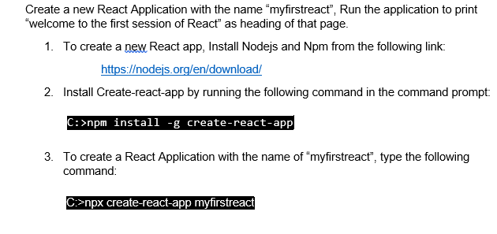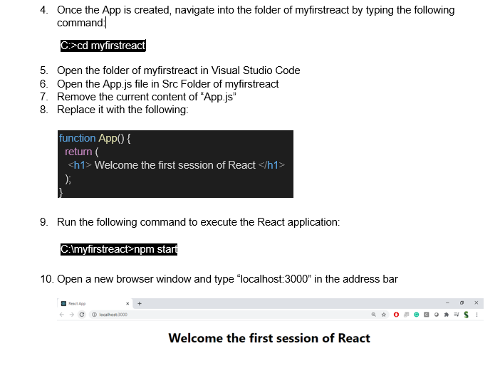

**Output**

